**Project Title: TechR Project 3:** **Stock Market Forecasting**

**Project Overview**:

Forecasting the price for the following - Day, Week, Month, (& subsequently Year)

Price points to be predicted

i. Day High

ii. Day Low

iii. Open

iv. Close

**Team Members**:

Individual.

**Project Timeline**:

# January 20, 2023 - Start Date.

# January 21, 2024 – Research on various methods for project completion.

# January 22, 2024 – Actual coding complete.

# January 23, 2024 – Documentation and submission of project complete.

**Tools and Technologies Used**:

Jupyter Notebook, Google Colab

<https://tradingeconomics.com/nifty:ind>

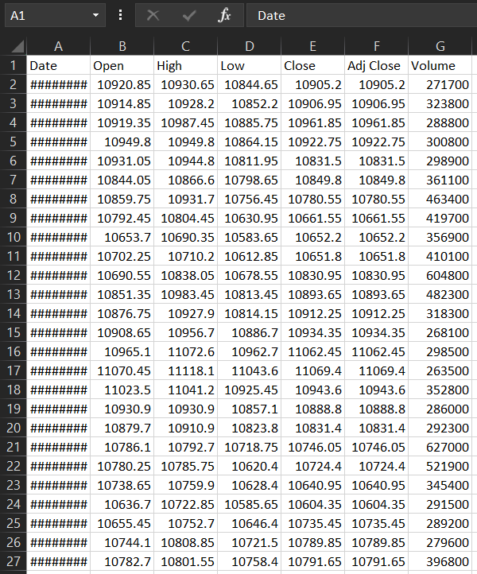**Dataset Description**:

A .csv file of NIFTY Stock values with almost 1230 rows.

**Model Architecture**:

The type of model that I have built is a Stacked LSTM model.

LSTM (Long Short-Term Memory) networks are a type of recurrent neural network (RNN) designed to address the vanishing gradient problem and better capture long-term dependencies in sequential data.

Stacking LSTMs refers to the practice of using multiple layers of LSTM cells in a neural network architecture.

Stacking LSTMs can capture hierarchical patterns and dependencies in sequential data more effectively, leading to improved model performance.

**Training Process**:

For building the Stacked LSTM Model, **Train-Test Split** Method was used.

The Train-Test split in this project was 65:35.

The first step in the training was to convert an array of values into a dataset matrix.

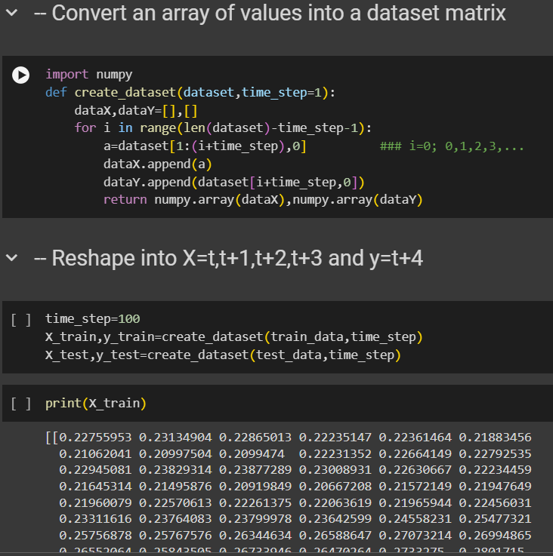The next step was to reshape the matrix in the appropriate conditions.

**Model Evaluation**:

For creating a Stacked LSTM Model, we first need to run the epochs on given dataset, and then we need to consider the performance metrics.

For this model, I have used RMSE (Root Mean Square Error) mechanism for finding the performsnce metrics.

Root mean square error can be expressed as

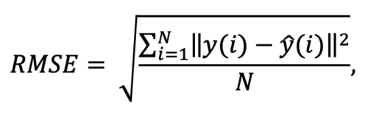

where N is the number of data points, y(i) is the i-th measurement, and y ̂(i) is its corresponding prediction.

In machine learning, it is extremely helpful to have a single number to judge a model’s performance, whether it be during training, cross-validation, or monitoring after deployment. Root mean square error is one of the most widely used measures for this. It is a proper scoring rule that is intuitive to understand and compatible with some of the most common statistical assumptions.

This is where RMSE plays an important role.

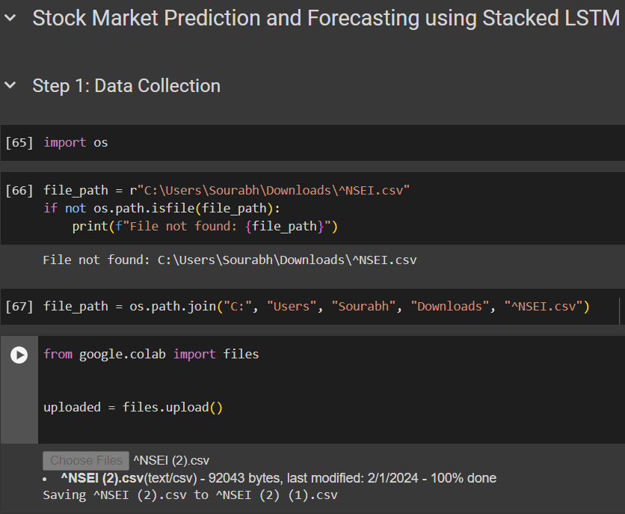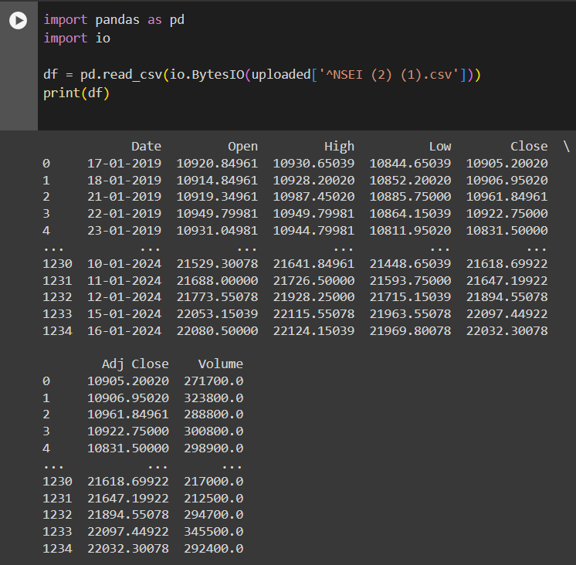**Results**:

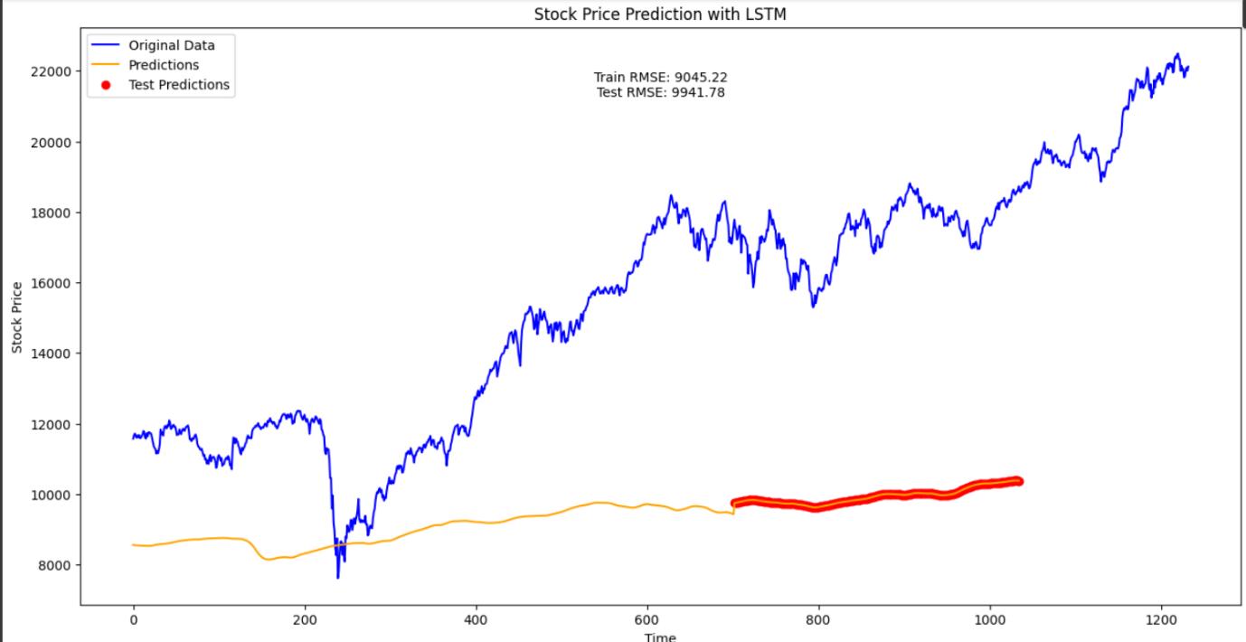

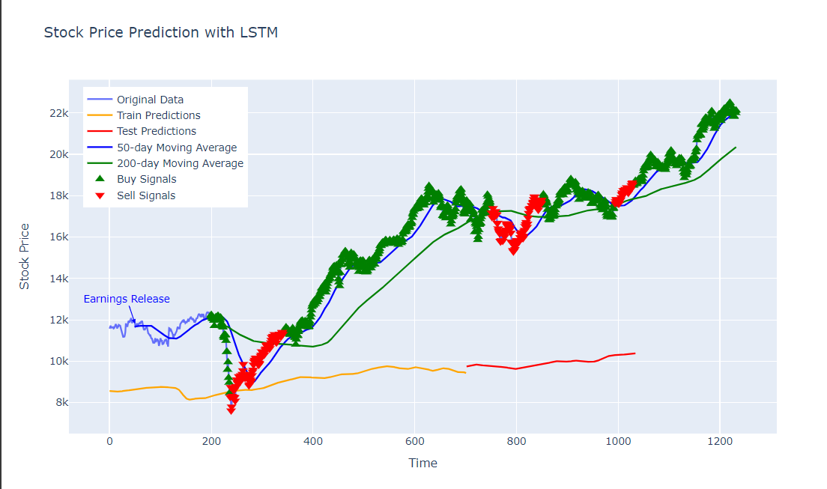

**Challenges Faced and Resolutions**:

Running the epochs proved to be a major challenge on Jupyter notebook, so I migrated to Google Colab, which offers a free online GPU for running epochs quickly and more effectively.

**Lessons Learned**:

The lesson I learnt throughout the duration of this project was **being patient.** Sometimes it might take up almost a day, for epochs to run, if you do not possess the computational power. The only alternatives you have in such conditions is to try and find different methods, or to be patient enough.

**Future Work**:

The future scope for Stock Market Forecasting can be vast. Here are some ways in which this project can be expanded:-

* **Incorporating Alternative Data Sources**: Explore the integration of alternative data sources such as social media sentiment, macroeconomic indicators, and supply chain data to augment traditional financial data for more accurate and robust predictions.
* **Deep Learning Architectures**: Investigate the use of advanced deep learning architectures such as recurrent neural networks (RNNs) and transformer models to capture complex temporal dependencies and nonlinear patterns in financial time series data.
* **Interpretable Machine Learning Models**: Develop interpretable machine learning models that provide insights into the underlying factors driving stock market movements, enabling investors to make more informed decisions and understand model predictions.
* **Ensemble Methods and Model Stacking:** Explore ensemble methods and model stacking techniques to combine predictions from multiple models, leveraging the strengths of each model and improving overall forecasting accuracy and robustness.
* **Reinforcement Learning for Portfolio Optimization:** Apply reinforcement learning algorithms to optimize portfolio allocation and trading strategies dynamically based on real-time market conditions, risk preferences, and investment objectives.
* **Quantum Machine Learning:** Investigate the potential of quantum machine learning techniques to tackle complex optimization problems in portfolio management and enhance the efficiency and scalability of stock market forecasting models.
* **Explainable AI for Risk Management:** Develop explainable AI techniques to quantify and mitigate risks associated with stock market investments, providing transparent risk assessments and insights into potential downside scenarios.
* Real-Time Forecasting and High-Frequency Trading: Design real-time forecasting models capable of processing and analyzing streaming market data to make timely trading decisions in high-frequency trading environments, leveraging low-latency computing infrastructure.
* Cross-Market Analysis and Transfer Learning: Explore cross-market analysis and transfer learning approaches to transfer knowledge and insights from one market to another, especially in global financial markets with interconnected dynamics.

**Conclusion**:

In conclusion, the project was a greatly informative one, and I learnt many new concepts like LSTM, Stacked LSTM and RMSE mechanism.